
RAMAIAH
INSTITUTE OF TECHNOLOGY
USN | 1 | M | S

(Autonomous Institute, Affiliated to VTU)
(Approved by AICTE, New Delhi & Govt. of Karnataka) Accredited by NBA & NAAC with ‘A’ Grade

SEMESTER END EXAMINATIONS – JANUARY 2018

Course & Branch | : | B.E. : Common to all branches | Semester | : | I
Subject | : | Basic Electrical Engineering. | Max. Marks | : | 100
Subject Code | : | EE101/201 | Duration | : | 3 Hrs

Instructions to the Candidates:
- Answer one full question from each unit.

 |  | UNIT- I
1. | a) | A DC circuit comprises of the following arrangement : Resistor A is of value 25Ω and is connected in parallel with resistor B of unknown value. This combination is then connected in series with a third resistor C of value 5Ω . Find the voltage to be applied across the whole circuit and the value of resistor B, if the potential difference across C is 90 Volts, and the total power consumed is 4320 Watts . | CO4 | (07)
 | b) | State Kirchoff’s current and voltage laws and explain them with the help of examples. Write the sign convention clearly. | CO4 | (07)
 | c) | The self - inductance of a coil of 500 turns is 0.25H. 60% of the flux created by coil 1 is linked with the second coil having 1,000 turns. Calculate the mutual inductance between the coils. Also find the EMF induced in the second coil, when the current in the first coil changes at the rate of 100 Amp/Sec. | CO4 | (06)
2. | a) | What is earthling ? Why is it necessary ? (Detail all reasons). | CO1 | (05)
 | b) | Find current in all the resistors of the network given below. Also find the voltage across PQ and power dissipated in 10Ω resistor.  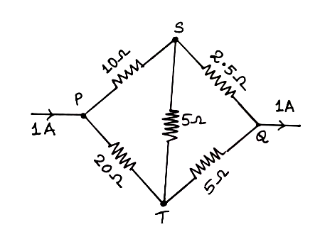 | CO4 | (07)
 | c) | List the conventional and non-conventional energy sources. Explain any one of these in detail. | CO1 | (08)
 |  | UNIT- II
3. | a) | With a neat diagram, derive an expression for the relationship between voltage and current in a series RLC circuit for XL = XC case and show that the average power dissipated is VI. Draw the waveforms of Voltage, Current and Power. | CO4 | (06)
 | b) | Derive an expression for R.M.S value and also define form factor and peak factor. | CO4 | (06)
 | c) | With reference to figure given below find the values of R and X so that V1=3V2 and V1 and V2 are in quadrature. Applied Voltage across AB is 240 V.  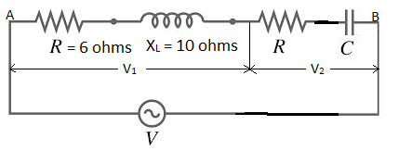 | CO4 | (08)
4. | a) | Draw the impedance triangle, voltage triangle and power triangle of a series RLC circuit for XL >XC and XL > XC cases. | CO4 | (06)
 | b) | An alternating voltage of (160+j120)V is applied to a circuit and the current in the circuit is given by (6+j8)A. Find  - Circuit constants.  - The power factor of the circuit.  - Power consumed. | CO4 | (06)
 | c) | Two coils A&B are connected in series across a 240V, 50Hz supply. The resistance of coil A is 5 ohms and the inductance of coil B is 0.015H. The input active and reactive powers from the supply is 3 KW and 2 KVAR respectively. Draw the power triangle. Find the inductance of coil A and resistance of coil B. Calculate the voltage across each coil. | CO4 | (08)
 |  | UNIT- III
5. | a) | A star connected load consists of 25Ω resistance in series with 15mH inductance in each phase. If the supply is 415V, 60Hz, find line current, power & pf. | CO5 | (06)
 | b) | Explain how three phase power and p.f can be measured using two wattmeters in a three phase balanced system. | CO5 | (08)
 | c) | A 500V, three phase Motor has output of 50hp and operating at p.f of 0.85 with efficiency of 90%. Find the readings of two wattmeters used to measure power. | CO5 | (06)
6. | a) | Two wattmeters are used to measure power input to a three phase circuit with lagging pf. If the readings were 10KW and 5KW, find the pf. If p.f changes to 0.6 leading, find the new wattmeter reading for the same input power. | CO5 | (07)
 | b) | Explain the working of a single phase induction type energy meter with necessary sketches of constructional details. | CO5 | (07)
 | c) | List the advantages of three phase system. | CO5 | (06)
 |  | UNIT- IV
7. | a) | With a neat sketch, explain the constructional features of a DC machine. | CO3 | (08)
 | b) | Explain the need for a starter in a DC motor. | CO3 | (05)
 | c) | An 8 pole lap connected armature driven at 350 rpm is required to generate 250 V. The useful flux per pole is about 0.045 Wb. If the armature has 120 slots, calculate a suitable number of conductors per slot. | CO3 | (07)
8. | a) | Derive an expression of torque developed in the armature of a DC motor. Draw the T vs I_{a} chs of DC shunt & series motor. | CO3 | (10)
 | b) | Obtain the e.m.f equation of an alternator with usual notations. | CO2 | (05)
 | c) | The armature resistance of 20hp, 250V series motor is 0.2 ohms and series field resistance is 0.02 ohms. When the series motor takes 60A, speed is 650 rpm. Find the speed when the current is 30 amps. | CO3 | (05)
 |  | UNIT- V
9. | a) | Explain the need for a starter in three phase induction motor. | CO2 | (04)
 | b) | A 25 kVA, 2200/250V transformer has an iron loss of 600W and full-load copper load of 1000W. Calculate:  - Efficiency at ½ full-load, UPF  - Losses at maximum efficiency  - Load for maximum efficiency  - Maximum efficiency at upf. | CO5 | (08)
 | c) | Explain with a neat diagram construction of:  - squirrel cage Induction motor  - slip-ring (phase wound) Induction motor. | CO2 | (08)
10. | a) | Can an induction motor run at synchronous speed? Explain. | CO2 | (05)
 | b) | With a neat diagram, explain the working of star delta starter for three phase induction motor. | CO2 | (07)
 | c) | With a neat diagram, explain the constructional details of:  - shell type transformer ii) core type transformer  Mention the merits and demerits of each type and mention their applications. | CO2 | (08)

****************

